**TRAVELMATE**

**Submitted by**

**PRARTHANA K-220701198**

***in partial fulfilment of the award of the degree***

***of***

# BACHELOR OF ENGINEERING

**IN**

**COMPUTER SCIENCE AND ENGINEERING**



# RAJALAKSHMI ENGINEERING COLLEGE

**AUTONOMOUS, CHENNAI**

**JULY-DEC 2024**

### 

**BONAFIDE CERTIFICATE**

Certified that this mini project “**TRAVELMATE**” is the bonafide work of “**PRARTHANA K - 2201701198”** who carried out the project work under my supervision.

|  |  |
| --- | --- |
|  | **SIGNATURE** |
|  | **Mrs. JANANEE V,** |
|  | Assistant Professor, |
|  | Computer Science & Engineering |
|  | Rajalakshmi Engineering College |
|  | Thandalam, Chennai -602105. |

Submitted for the End semester practical examination to be held on

**INTERNAL EXAMINER EXTERNAL EXAMINER**

### **ACKNOWLEDGEMENT**

I express my sincere thanks to my beloved and honourable chairman **MR.S.MEGANATHAN** and the chairperson **DR.M.THANGAM MEGANATHAN** for their timely support and encouragement.

I am greatly indebted to my respected and honourable principal **Dr. S.N.MURUGESAN**for his able support and guidance.

No words of gratitude will suffice for the unquestioning support extended to us by my head of the department **Dr. P. KUMAR**, and my Academic Head **Dr.SABITHA**, for being ever supporting force during my project work.

I also extend my sincere and hearty thanks to my internal guide **Mrs. JANANEE V** for her valuable guidance and motivation during the completion of this project.

My sincere thanks to my family members, friends and other staff members of Computer Science and Engineering.

PRARTHANA K 220701198

**ABSTRACT**

TravelMate is an all-in-one platform aimed at enhancing the travel experience for both solo travelers and groups by fostering a sense of community and offering budget-friendly solutions. In today’s world, where travel has become more accessible, many individuals seek authentic, safe, and connected experiences. TravelMate addresses these needs by enabling users to connect with like-minded travelers based on shared interests, activities, and destinations, creating a sense of belonging even when far from home.

The platform offers a robust community system where users can join or create travel groups centered around specific locations or shared hobbies, such as adventure sports, cultural exploration, or eco-tourism. These communities provide a space for travelers to exchange advice, plan trips together, and share real-time updates. Whether users are traveling solo and looking for companionship or in groups seeking new members, TravelMate makes connecting easy and seamless.

One of the standout features of TravelMate is its integrated rental service, designed to reduce the financial burden associated with purchasing expensive travel gear. From camping equipment and hiking gear to photography tools, users can rent high-quality, costly items for a fraction of the purchase price. This makes the platform especially valuable for group travelers, as it enables shared rentals, further reducing individual costs. By opting for rentals, users can access premium equipment that enhances their travel experience without the long-term commitment of ownership, making it a perfect solution for those who travel occasionally or try new activities.

**TABLE OF CONTENTS**

**CHAPTER TITLE PAGE NO**

1. **INTRODUCTION** 
   1. **MOTIVATION BEHIND TRAVELMATE 6**
   2. **PURPOSE AND OBJECTIVES 7**
   3. **TARGET USERS 8**
   4. **MODULES 9**
2. **SYSTEM SPECIFICATIONS**

**2.1 SOFTWARE SPECIFICATIONS 10**

1. **ARCHITECTURE DIAGRAM 11**
2. **MODULE DESCRIPTION 12**
3. **SYSTEM DESIGN**
   1. **USE CASE DIAGRAM 13**
4. **SAMPLE CODING 15**
5. **SCREEN SHOTS 23**
6. **CONCLUSION 28**
7. **REFERENCES 29**

**CHAPTER 1**

**1.INTRODUCTION**

TravelMate is an innovative platform designed to enhance the travel experience by connecting solo and group travelers based on shared interests and destinations. It promotes community engagement by allowing users to join or create travel groups centered around specific locations or activities, fostering meaningful connections and collaborations.

A key feature of TravelMate is its budget-friendly rental service, which allows travelers to rent expensive gear like camping and hiking equipment. This reduces the financial burden on users, particularly for those who only need such items for short trips or group adventures.

By blending community building with cost-effective gear rental, TravelMate offers a complete solution for travelers looking to explore new destinations while staying within their budget.

**1.1 Motivation behind travelmate :**

The primary motivation behind TravelMate stems from the growing desire for personalized, meaningful travel experiences, coupled with the challenges that modern travelers face in terms of affordability and social connection. As solo travel becomes more popular and group travel continues to evolve, many travelers struggle to connect with like-minded individuals, share costs, or access expensive travel gear for short-term use. These challenges can limit the scope and enjoyment of travel, particularly for those on a budget or traveling alone.

Many travelers seek to connect with others who share their interests or destinations, but current platforms often lack the depth of engagement needed to form lasting connections. Additionally, the cost of travel gear, such as hiking equipment, photography tools, and camping gear, can be prohibitively expensive for occasional use, discouraging many from pursuing their dream adventures. TravelMate was created to address these pain points by fostering a sense of community among travelers and providing budget-friendly solutions.

**1.2 Purpose and Objectives of TravelMate:**

**Purpose:** The primary purpose of TravelMate is to create a platform that enhances the travel experience by fostering connections among solo and group travelers while offering cost-effective solutions for travel gear. TravelMate aims to build a global community of travelers who can share experiences, plan trips together, and reduce their travel expenses by renting essential gear instead of purchasing it. The platform seeks to make travel more accessible, affordable, and socially engaging.

**Objectives:**

1. **Facilitate Community Building:** Create a space where solo travelers and groups can connect with others who share similar interests or are traveling to the same destinations. The platform will provide features for joining or forming travel communities, allowing users to plan and coordinate their trips together.
2. **Promote Budget-Friendly Travel:** Offer a rental service that allows travelers to rent costly travel gear like camping equipment and hiking gear. This feature will help users save on unnecessary purchases, making travel more affordable, especially for occasional travelers and groups who can share rental costs.
3. **Enhance Travel Experiences Through Collaboration:** Enable users to collaborate, share advice, and coordinate group travel, fostering meaningful relationships among travelers. This will enhance the quality of the travel experience by promoting shared activities and authentic interactions.
4. **Simplify Trip Planning:** Provide easy-to-use tools for travelers to search for destinations, communities, and available gear, streamlining the planning process. The platform will offer a seamless user interface that encourages efficient trip organization.
5. **Support Sustainable Travel Practices:** By promoting the rental of travel gear, TravelMate aims to reduce waste associated with the purchase of single-use or rarely-used travel items. This supports environmentally conscious and sustainable travel practices.

In summary, TravelMate’s objectives focus on community building, affordability, and creating a socially and economically sustainable travel ecosystem.

**1.3. Target Users of TravelMate:**

1. Solo Travelers: Individuals who prefer to travel alone but seek the opportunity to connect with others during their journey. TravelMate helps solo travelers find like-minded companions and join communities that share similar interests or destinations, enhancing their travel experience while reducing feelings of isolation.
2. Group Travelers: Friends, families, or organized groups who travel together and want to coordinate their plans more efficiently. TravelMate allows group travelers to collaborate, plan trips, and share rental gear, making group travel more affordable and organized.
3. Budget-Conscious Travelers: Travelers who are looking to minimize costs by renting expensive travel gear instead of buying it. This category includes students, backpackers, and adventure enthusiasts who want to enjoy travel without incurring high expenses.
4. Adventure Enthusiasts: Individuals interested in outdoor activities such as hiking, camping, and extreme sports who need access to specialized travel gear. TravelMate offers a rental service for expensive gear, allowing them to enjoy their hobbies without the financial burden of purchasing equipment.
5. Frequent Travelers: People who travel often for leisure, work, or exploration and need a platform to connect with other frequent travelers. They benefit from the community aspect of TravelMate, allowing them to find new companions and efficiently manage their travel gear needs.
6. Travel Organizers or Influencers: Travel influencers or organizers who plan trips for others can use TravelMate to engage with potential travelers, build communities around specific destinations or themes, and offer guidance and insights.

By catering to these diverse groups, TravelMate aims to create a vibrant, connected travel community that benefits both casual and frequent travelers, enhancing their experiences while making travel more accessible and affordable.

**1.3. Modules:**

**1. Login and signup page :**

* User login
* User signup

**2. Homepage :**

* Hero Section
* Search Bar
* Featured Destinations
* Join a Community
* Testimonials & Reviews

**3. Destinations page:**

* Top destinations to visit

**4. Communities page :**

* Popular travel communities
* Joining a community
* Community joining form
* Joining the community whatsapp group
* Traveller tips
* Travellers reviews

**5. Rent gear :**

* Rental products
* Add to cart

**6.Contact us :**

* Messages or queries to be asked

**CHAPTER 2**

**SYSTEM SPECIFICATIONS**

**2.1. SOFTWARE SPECIFICATIONS**

Operating System : WINDOWS 11

Front – End : HTML, CSS, JAVASCRIPT

Back – End : PHP, XAMPP

**CHAPTER 3**

**ARCHITECTURE DIAGRAM**

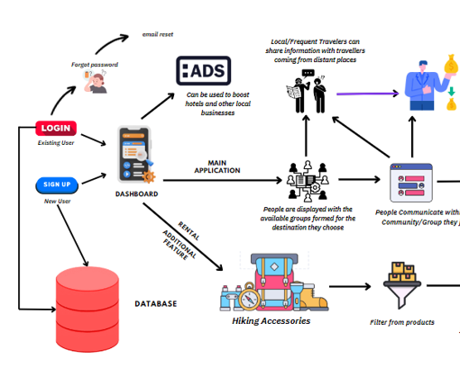

**CHAPTER 4**

**MODULE DESCRIPTION**

**4.1. Login and Signup Module**

The Login and Signup module allows users to securely access their accounts and register for new accounts on the TravelMate platform. These two pages ensure users can easily log in to access personalized features or create a new account to join the platform.

1. Login Page

* Purpose: The login page enables returning users to securely access their accounts using their email and password.
* Key Features:
  + Email and Password Fields:
    - Users can enter their registered email and password to log in.
    - Validation is enforced for correct formats (e.g., a valid email structure).
  + Login Button:
    - A clear and prominent "Login" button submits the credentials for authentication.
  + Navigation to Signup:
    - Users who don’t have an account are prompted with a link to the signup page (“Don’t have an account? Sign up here”).

2. Signup Page

* Purpose: The signup page allows new users to create a TravelMate account by filling out a form with their basic information.
* Key Features:
  + Name Field:
    - Users input their full name for profile creation.
  + Email Field:
    - A valid email address is required for account creation and further communication.
  + Password Fields:
    - Password input field with validation to ensure strong passwords.
    - A second "Confirm Password" field ensures that users have entered the correct password by requiring it to be typed again.
  + Signup Button:
    - A clear call-to-action button to submit the signup form and create the account.
  + Navigation to Login:
    - Existing users are prompted to go back to the login page if they already have an account (“Already have an account? Login here”).
  + Form Validation:
    - Ensures that all fields are filled out correctly before submission (e.g., password confirmation and email validation)

**4.2. Homepage Module**

The homepage serves as the central hub for the TravelMate platform, offering users an inviting introduction to the platform’s core features and guiding them to explore destinations, communities, and travel gear. The homepage is designed with a visually captivating interface, featuring video backgrounds, search functionality, and quick access to essential parts of the website.

Key Components:

1. Header Section:
   * Logo:
     + The TravelMate logo is prominently displayed to reinforce brand identity.
   * Navigation Bar:
     + A dropdown menu with links to key pages (Destinations, Communities, Rent Gear, and Logout) provides easy access to important sections of the website.
   * Responsive Design:
     + The navigation bar is mobile-friendly, ensuring usability across devices.
2. Hero Section:
   * Background Video:
     + A dynamic video showcasing scenic travel footage creates an immersive and engaging experience for users.
   * Headline and Tagline:
     + The headline (“Explore the World with Like-Minded Travelers”) and tagline clearly communicate the platform's value proposition.
   * Search Bar:
     + A central search bar allows users to search for destinations, gear rentals, and communities.
     + The search functionality includes keyword-based redirection to relevant pages (e.g., destinations, communities, rentals).
3. Features Section:
   * Key Features Overview:
     + Three core features of TravelMate (Connect with Travelers, Rent Travel Gear, Join Travel Communities) are highlighted to give users a clear understanding of the platform's offerings.
   * Feature Descriptions:
     + Brief descriptions accompany each feature to encourage exploration.
4. Call to Action (CTA) Section:
   * Headline and CTA Button:
     + A strong call-to-action encourages users to "Start Your Journey with TravelMate Today" and includes a "Join Now" button that directs them to the community page, prompting new signups and engagement.
5. Featured Destinations Section:
   * Highlighting Top Travel Destinations:
     + The section displays visually appealing images of popular destinations (Paris, Tokyo, Bali) with short descriptions, enticing users to explore these locations through TravelMate’s communities.
   * Explore More Button:
     + A button linking to the full Destinations page encourages users to discover additional travel locations.
6. Testimonials Section:
   * User Testimonials:
     + Real reviews from travelers provide social proof and build trust, showcasing the benefits users have experienced using TravelMate.
   * Testimonial Grid:
     + A grid layout makes testimonials easy to read and visually pleasing.
7. Footer Section:
   * Legal and Contact Links:
     + Links to important pages such as Privacy Policy, Terms of Service, and Contact Us offer easy navigation for users seeking further information.
   * Copyright Notice:
     + Copyright information is displayed to protect intellectual property and establish brand ownership.

Interactive Features:

* Search Functionality:
  + A search bar with intuitive keyword detection guides users to specific pages based on their input (e.g., destinations, communities, gear rentals).
  + If no matching results are found, an alert prompts the user to refine their search.

**4.3. Destinations Module**

The Destinations page is designed to provide users with detailed insights into some of the most exciting travel locations around the world. It serves as a resource for users to explore top destinations, learn more about each location, and discover new places for their next adventure. The page is visually driven, featuring high-quality images and informative descriptions for each destination, along with external links for users to dive deeper into specific places.

Key Components:

1. Header Section:
   * Logo:
     + The TravelMate logo is placed at the top to maintain brand recognition and consistency across pages.
   * Navigation Bar:
     + Links to the Home page and a dropdown menu with additional options (Communities, Rent Gear, Logout) offer easy navigation to other sections of the site.
   * Responsive Design:
     + The header adapts seamlessly to various screen sizes, ensuring a user-friendly experience on mobile and desktop devices.
2. Destinations Section:
   * Grid Layout:
     + The top destinations are presented in a grid format, each featuring an image, title, description, and call-to-action button. This clean, organized layout allows users to easily browse through different options.
   * Featured Destinations:
     + The page highlights diverse destinations, from tropical getaways (e.g., Maldives, Bali, Thailand) to cultural cities (e.g., Paris, Tokyo, Barcelona) and scenic natural wonders (e.g., Swiss Alps, Georgia).
   * Destination Descriptions:
     + Each destination includes a brief description to give users a snapshot of what to expect at each location, making the content both informative and engaging.
   * Call-to-Action Buttons:
     + Every destination block features a "Learn More" button that links to relevant external resources (e.g., Wikipedia pages) for users who want additional information about each destination.
3. External Links to Additional Information:
   * Learn More Buttons:
     + These buttons provide direct access to Wikipedia articles, allowing users to dive deeper into the history, culture, and highlights of each destination, expanding their knowledge and planning resources.

**4.4. Community Module :**

The Community module of TravelMate is designed to help travelers connect with like-minded individuals by joining specific interest-based groups. This module fosters a sense of belonging and shared experiences, allowing travelers to participate in communities that align with their travel preferences. Each community has its own space, where users can interact, share tips, and organize events. Additionally, users can join these communities through dedicated community joining pages that capture basic user information.

Key Components:

1. Header Section:
   * Logo and Navigation:
     + The TravelMate logo is featured prominently, maintaining brand identity.
     + Navigation links provide easy access to essential pages like Home, Communities, Destinations, Rent Gear, and Login, ensuring seamless browsing across the site.
2. Community Hero Section:
   * Background Video:
     + A dynamic video of travel scenes plays in the background, providing a visually engaging element that appeals to adventure seekers.
   * Hero Content:
     + A tagline ("Join Communities of Like-Minded Travelers") and a brief introductory paragraph encourage users to explore and become part of travel groups that suit their preferences.
     + The description emphasizes the camaraderie, shared experiences, and valuable tips users can gain by joining communities.
3. Popular Communities Section:
   * Community List:
     + This section highlights some of the most popular travel communities within the platform, including:
       - Hiking Enthusiasts: For users passionate about outdoor adventures and mountain treks.
       - Beach Lovers: A community focused on tropical destinations and beach getaways.
       - History Buffs: For users interested in exploring historical landmarks and understanding cultural heritage.
       - Photography Explorers: For photographers who want to share their travel photos and learn new skills from fellow members.
   * Community Cards:
     + Each community is presented as a card with:
       - A high-quality representative image.
       - A brief description of what the community offers.
       - A "Join Now" button that leads to the respective community’s joining page for registration.
   * Diverse Communities:
     + The community choices cover a wide range of travel interests, making it easier for users to find a group that resonates with their personal preferences and travel styles.
4. Traveler Tips Section:
   * Useful Travel Tips:
     + A short list of practical tips for travelers, such as packing light, staying connected, documenting journeys, and researching destinations. This adds value to the page by offering general advice to enhance users' travel experiences.
5. Testimonials Section:
   * User Feedback:
     + This section features quotes from satisfied TravelMate users, highlighting their positive experiences with the platform. For instance:
       - Sarah K. shares how TravelMate helped her make lifelong friends.
       - John D. praises the photography workshops organized by the platform.
       - Emily R. appreciates the support and motivation she received from the hiking community.
   * Trust-Building:
     + These testimonials build credibility and encourage new users to engage with the communities by showcasing the benefits of being part of TravelMate’s groups.
6. Join Us Section:
   * Call to Action:
     + A clear invitation for users to become part of the TravelMate community, emphasizing the platform’s role in helping travelers connect and share their journeys.
7. Footer Section:
   * Footer Links:
     + Quick access to important information like the Privacy Policy, Terms of Service, and Contact Us pages, ensuring transparency and ease of communication.
8. Community Joining Pages:

* Community-Specific Branding:
  + The joining page reflects the theme of the specific community, e.g., Hiking Enthusiasts. The title of the page clearly states the name of the community, and a relevant introduction is provided to engage users.
* Registration Form:
  + Form Elements:
    - A form is presented to collect basic information such as:
      * Name: The user’s full name.
      * Age: Users must be over a certain age (minimum 18).
      * Phone: Contact information for community communication, validated with a 10-digit pattern.
  + Submit Button:
    - The form includes a "Submit" button that processes the user's registration request, enabling them to join the community.
* Data Validation:
  + Input fields such as age and phone number are validated to ensure correct and complete information is provided before submission.
* User-Friendly Interface:
  + The form is straightforward, with clear instructions, ensuring users can quickly and easily register to become part of their chosen community.

**4.5. Rent Gear Module :**

The Rent Gear Module is designed to provide travelers with an affordable and convenient way to rent essential travel equipment for their adventures. This module not only helps users save money by eliminating the need to purchase expensive gear but also ensures they have access to high-quality equipment for their trips.

Key Features:

1. Diverse Selection of Gear:
   * The module offers a wide variety of travel gear for rent, including camping tents, travel backpacks, action cameras, and sleeping bags. Each item is carefully selected to meet the diverse needs of travelers, whether they are going on a hiking expedition, a beach vacation, or an outdoor adventure.
2. Affordable Pricing:
   * Users can rent gear at competitive daily rates, making travel more budget-friendly. Pricing is clearly displayed next to each item, allowing users to make informed choices based on their budgets.
3. User-Friendly Interface:
   * The rental page features a clean and intuitive layout that makes it easy for users to browse available gear. Each product includes an image, description, and rental price, along with an "Add to Cart" button for a seamless shopping experience.
4. Cart Management:
   * Users can easily add items to their cart, view their selected products, and see the total cost of their rental. The cart section updates dynamically, providing real-time feedback on their selections.
5. Checkout Process:
   * Once users are ready to complete their rental, they can proceed to checkout, where they can review their items and total cost. This streamlines the rental process, making it quick and efficient.
6. Backend Integration:
   * The module is integrated with backend functionality that allows for the management of rental items, including availability checks and order processing. This ensures that users can only rent items that are currently available, reducing the likelihood of double bookings.
7. Database Interaction:
   * The rental module communicates with the database to track user interactions, such as adding items to the cart and processing rental requests. This functionality supports a smooth user experience and efficient inventory management.

**4.6. Contact Module :**

The Contact Module serves as a vital communication channel between TravelMate and its users. This module is designed to facilitate user inquiries, feedback, and support requests, ensuring that travelers can easily reach out for assistance or share their experiences.

Key Features:

1. User-Friendly Interface:
   * The contact page features a clean and intuitive layout, making it easy for users to navigate and fill out the contact form. Clear labels and placeholders guide users through the process, ensuring a smooth experience.
2. Contact Form:
   * Users can reach out to TravelMate by filling out a simple contact form that includes fields for their name, email address, and message. This straightforward design encourages user interaction and allows for quick submissions.
3. Validation and Required Fields:
   * The contact form includes validation to ensure that users provide all necessary information before submitting their messages. Required fields are marked clearly, reducing the likelihood of incomplete submissions.
4. Responsive Design:
   * The contact module is designed to be fully responsive, ensuring accessibility on various devices, including smartphones, tablets, and desktop computers. This flexibility allows users to reach out from anywhere, at any time.
5. Backend Integration:
   * The contact module connects to a backend script (e.g., submit_contact.php) that processes form submissions. This integration allows messages to be securely sent and stored, ensuring timely responses from the TravelMate team.

**CHAPTER 5**

**SYSTEM DESIGN**

**5.1 USE CASE DIAGRAM**

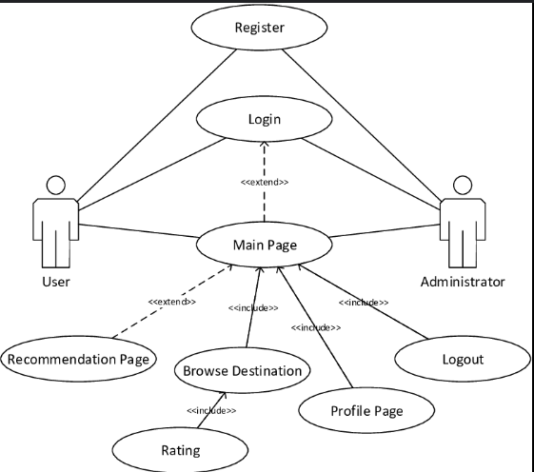

**CHAPTER6**

**SAMPLECODING**

<!DOCTYPE html>

<html lang="en">

<head>

    <meta charset="UTF-8">

    <meta name="viewport" content="width=device-width, initial-scale=1.0">

    <meta name="description" content="TravelMate - Connect with like-minded travelers and access affordable travel gear.">

    <title>TravelMate - Your Ultimate Travel Companion</title>

    <link rel="stylesheet" href="styles.css">

    <link rel="stylesheet" href="https://fonts.googleapis.com/css?family=Merriweather|Open+Sans">

</head>

<body>

    <!-- Header Section -->

    <header>

        <nav>

            <div class="logo">

                <h1>TravelMate</h1>

            </div>

            <ul class="nav-links">

                <li class="dropdown">

                    <a href="#" class="dropdown-toggle">&#9662;</a>

                    <ul class="dropdown-menu">

                        <li><a href="destination.html">Destinations</a></li>

                        <li><a href="community.html">Communities</a></li>

                        <li><a href="rental.html">Rent Gear</a></li>

                        <li><a href="index.html">Logout</a></li>

                    </ul>

                </li>

            </ul>

        </nav>

    </header>

    <!-- Hero Section -->

    <section class="hero">

        <video autoplay muted loop class="background-video">

            <source src="explore.mp4" type="video/mp4">

            Your browser does not support the video tag.

        </video>

        <div class="hero-content">

            <h2>Explore the World with Like-Minded Travelers</h2>

            <p>Find your travel mates, share experiences, and explore new destinations together.</p>

            <div class="search-bar">

                <input type="text" id="searchInput" placeholder="Search destinations, gear, or travelers...">

                <button id="searchBtn">Search</button>

            </div>

        </div>

    </section>

    <!-- Features Section -->

    <section class="features">

        <div class="feature">

            <h3>Connect with Travelers</h3>

            <p>Match with solo or group travelers based on interests and destinations.</p>

        </div>

        <div class="feature">

            <h3>Rent Travel Gear</h3>

            <p>Access affordable travel gear for your next adventure.</p>

        </div>

        <div class="feature">

            <h3>Join Travel Communities</h3>

            <p>Be a part of our growing travel community and make lifelong connections.</p>

        </div>

    </section>

    <!-- Call to Action Section -->

    <section class="cta">

        <h2>Start Your Journey with TravelMate Today!</h2>

        <p>Whether you’re looking for a solo adventure or a group trip, we’ve got you covered. Join now and explore the world!</p>

        <div>

            <a href="community.html" class="button">Join Now</a>

        </div>

    </section>

    <!-- Featured Destinations Section -->

<section class="featured-destinations">

    <h2>Top Travel Destinations</h2>

    <div class="destinations-grid">

        <div class="destination">

            <img src="https://cdn.britannica.com/31/255531-050-B7E07090/eiffel-tower-paris-france-champ-de-mars-view.jpg" alt="Paris" />

            <h3>Paris, France</h3>

            <p>Explore the city of love and lights with our travel communities.</p>

        </div>

        <div class="destination">

            <img src="https://offbeatjapan.com/wp-content/uploads/2011/10/tokyo-tower-night-landmark.jpg" alt="Tokyo" />

            <h3>Tokyo, Japan</h3>

            <p>Experience the vibrant culture and futuristic lifestyle of Tokyo.</p>

        </div>

        <div class="destination">

            <img src="https://media.digitalnomads.world/wp-content/uploads/2021/01/20120709/bali-for-digital-nomads.jpg" alt="Bali" />

            <h3>Bali, Indonesia</h3>

            <p>Find your zen in the serene and scenic landscapes of Bali.</p>

        </div>

    </div>

    <div></div>

    <div>

        <a href="destination.html" class="button">Explore more</a>

    </div>

</section>

<!-- Testimonials Section -->

<section class="testimonials">

    <h2>What Our Travelers Say</h2>

    <div class="testimonial-grid">

        <div class="testimonial">

            <p>"TravelMate made my solo trip so much easier! I found travel buddies and saved a lot on gear rentals."</p>

            <h4>- Sarah M.</h4>

        </div>

        <div class="testimonial">

            <p>"The community feature is great. I connected with a group of fellow hikers and it was a memorable experience."</p>

            <h4>- Mike J.</h4>

        </div>

        <div class="testimonial">

            <p>"Highly recommend TravelMate for anyone who wants affordable travel gear and amazing destination suggestions!"</p>

            <h4>- Emma T.</h4>

        </div>

    </div>

</section>

    <!-- Footer Section -->

    <footer>

        <div class="footer-content">

            <p>© 2024 TravelMate. All rights reserved.</p>

            <ul class="footer-links">

                <li><a href="privacy-policy.html">Privacy Policy</a></li>

                <li><a href="#">Terms of Service</a></li>

                <li><a href="contact.html">Contact Us</a></li>

            </ul>

        </div>

    </footer>

    <script>

        // Search functionality

        document.getElementById('searchBtn').addEventListener('click', function() {

            const searchInput = document.getElementById('searchInput').value.toLowerCase();

            // Keyword matching and redirection

            if (searchInput.includes('destination') || searchInput.includes('give me suggestion for destinations to visit')) {

                window.location.href = 'destination.html';

            } else if (searchInput.includes('community') || searchInput.includes('communities') || searchInput.includes('how to join community')) {

                window.location.href = 'community.html';

            } else if (searchInput.includes('gear') || searchInput.includes('rent') || searchInput.includes('how to rent products')) {

                window.location.href = 'rental.html';

            } else if (searchInput.includes('contact') || searchInput.includes('how to contact')) {

                window.location.href = 'contact.html';

            } else if (searchInput.includes('do you have hiking community') || searchInput.includes('I want to join hiking community')) {

                window.location.href = 'hiking.html';

            } else if (searchInput.includes('do you have beach community') || searchInput.includes('I want to join beach lovers community')) {

                window.location.href = 'beach.html';

            } else if (searchInput.includes('do you have historical places community') || searchInput.includes('I want to join historical places community')) {

                window.location.href = 'history buffs.html';

            } else if (searchInput.includes('policy') || searchInput.includes('what are your policies')) {

                window.location.href = 'privacy-policy.html';

            } else if (searchInput.includes('login')) {

                window.location.href = 'login.html';

            } else {

                alert('No matching page found. Try searching for "destinations", "communities", "gear", or "login".');

            }

        });

    </script>

</body>

</html>

**CHAPTER7**

**SCREENSHOTS**

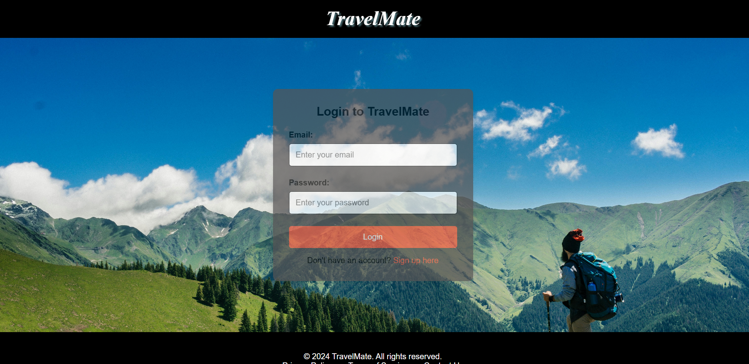

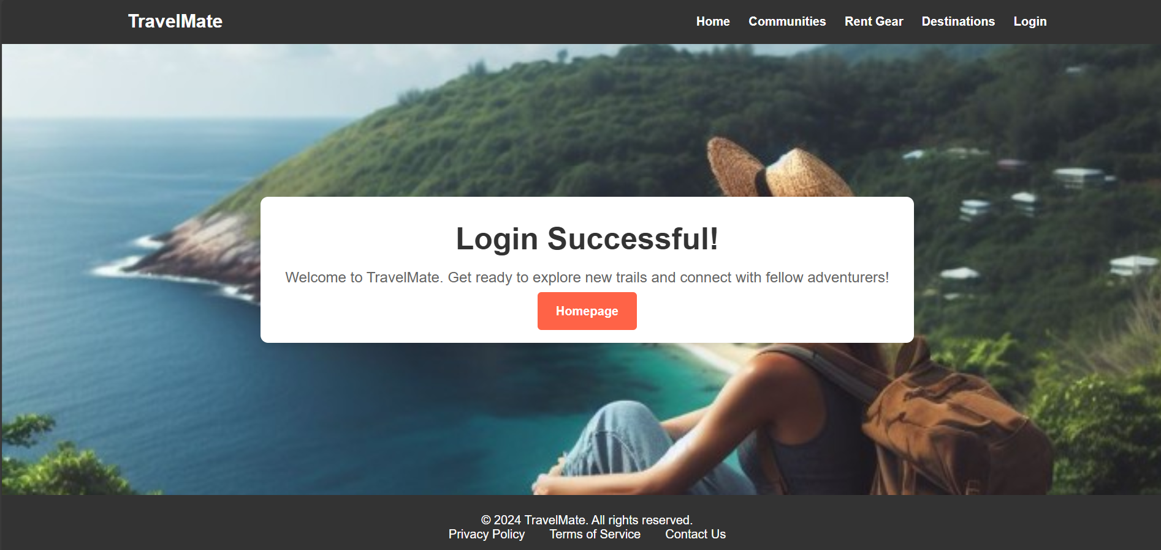

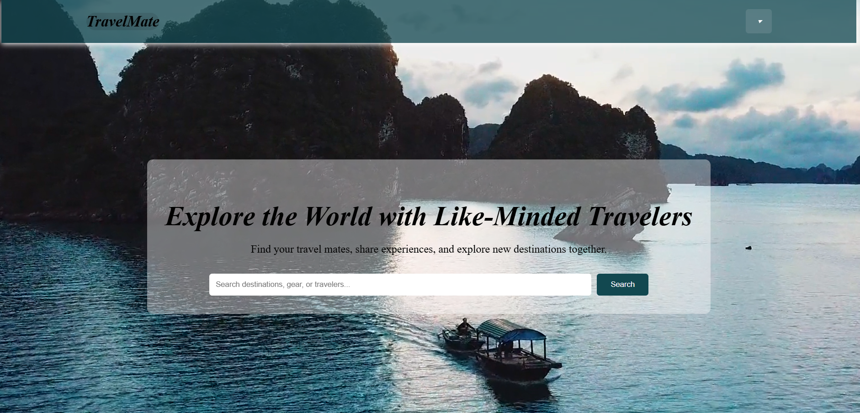

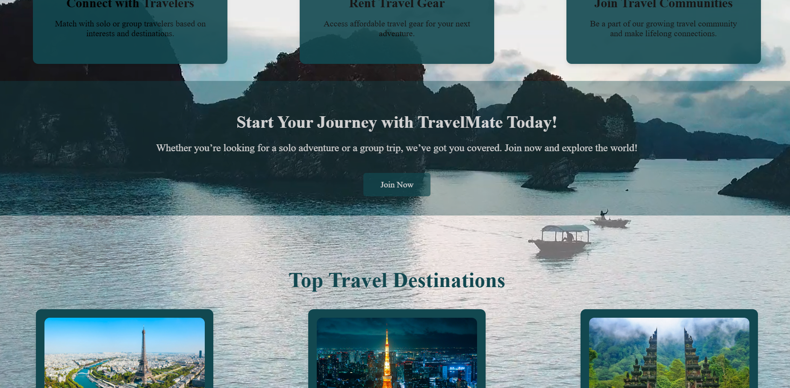

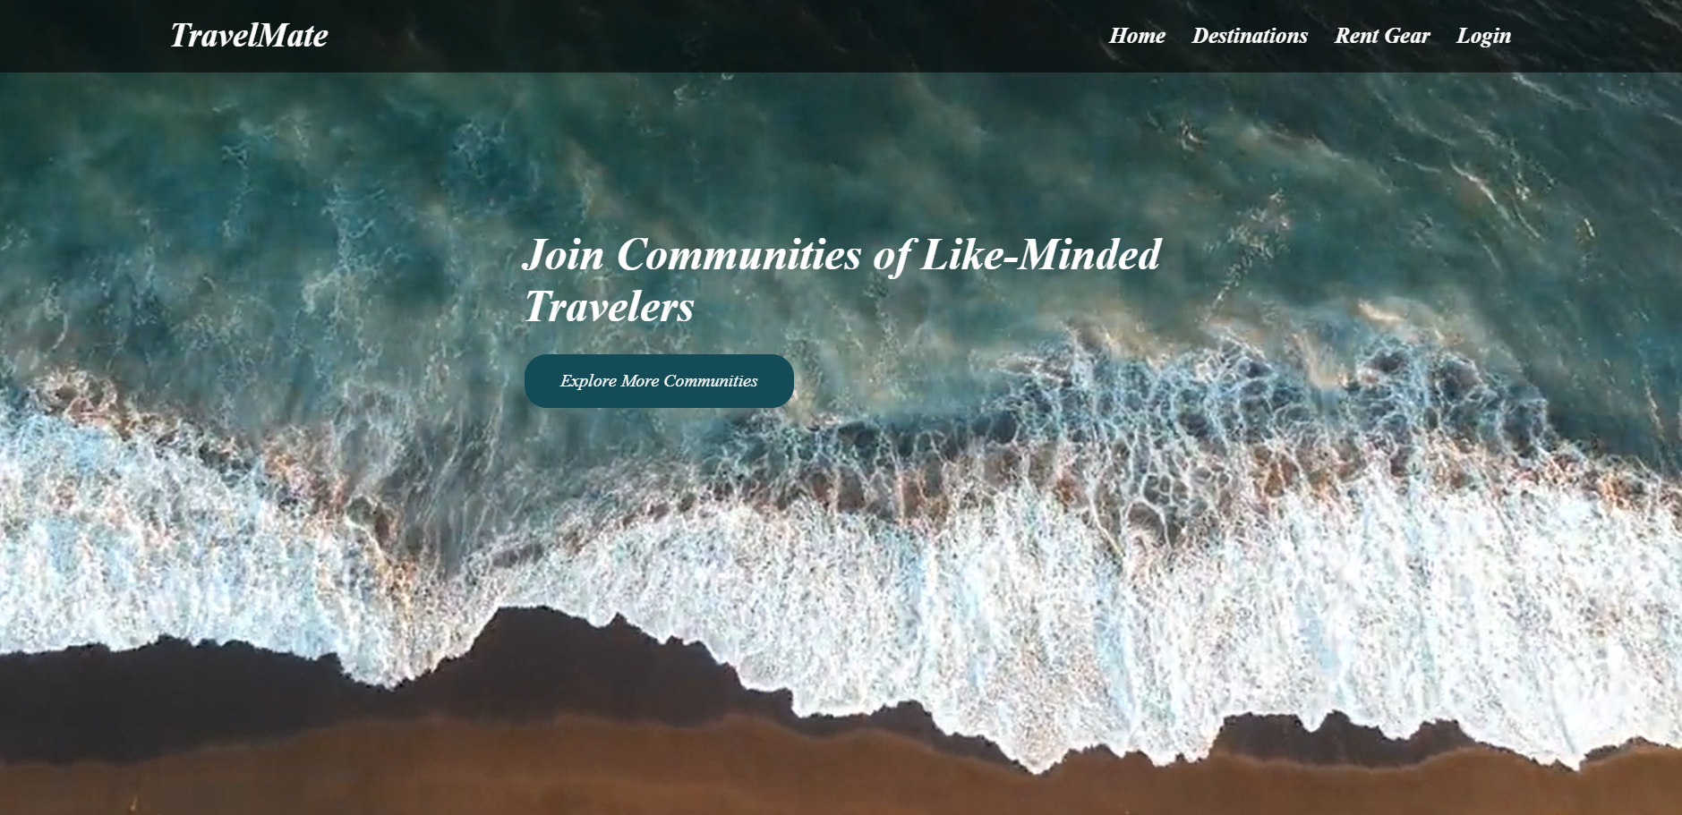

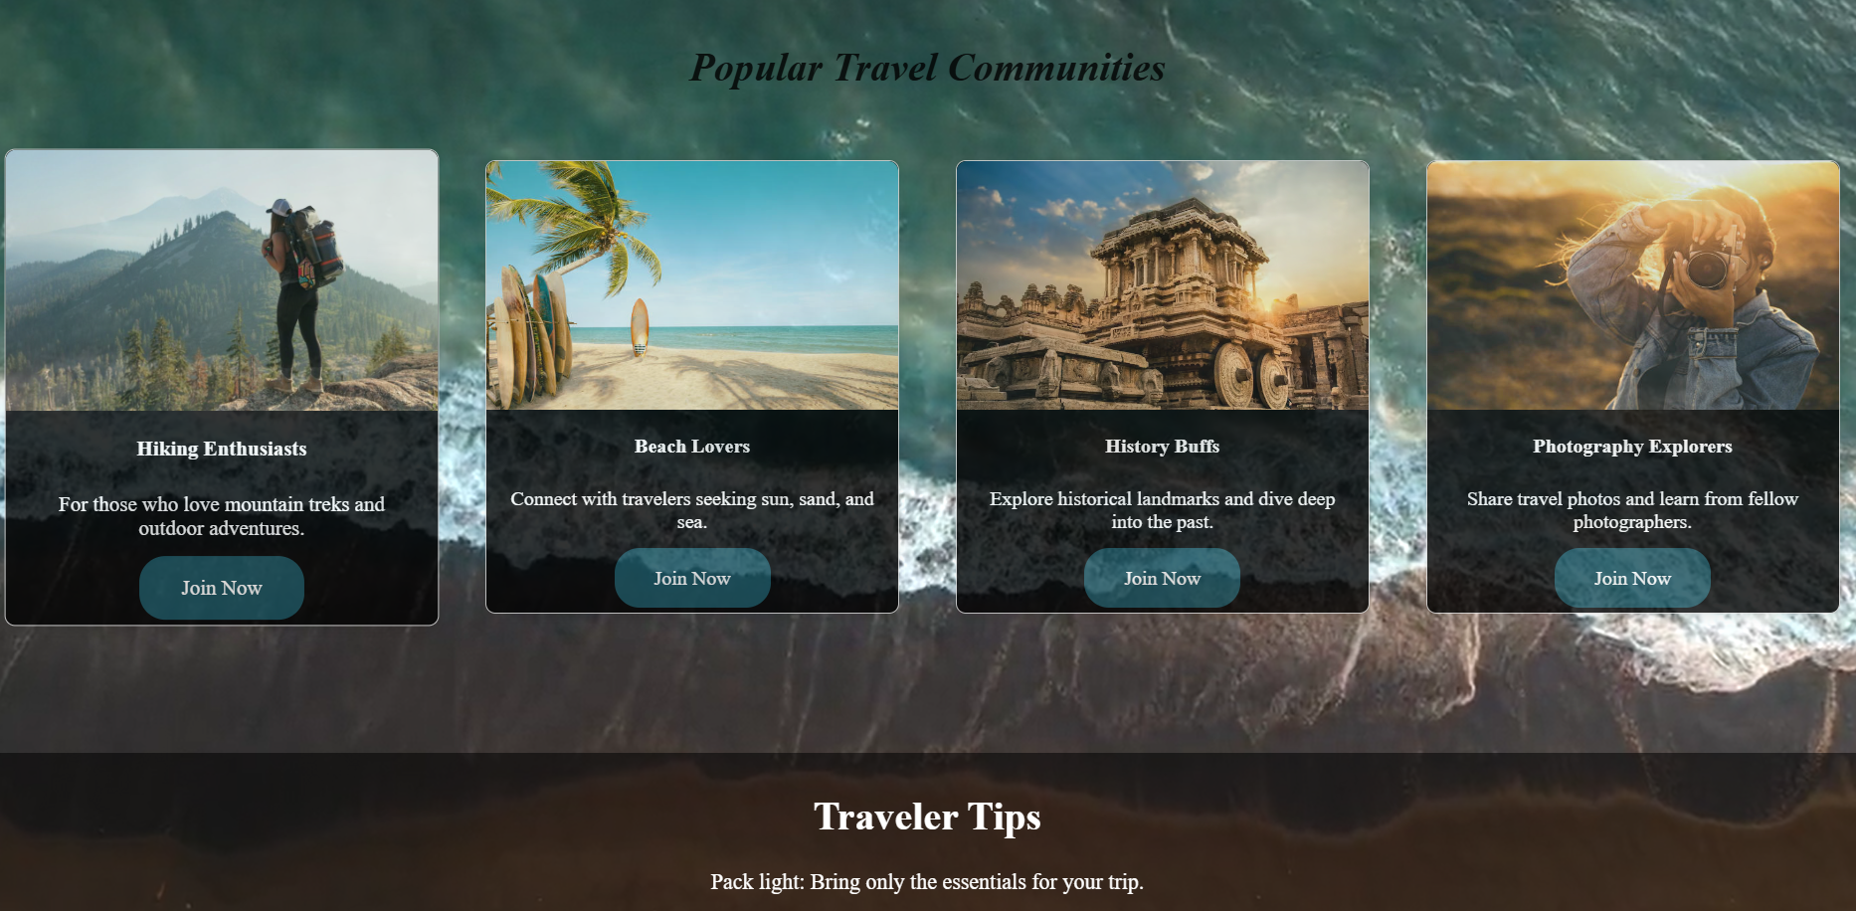

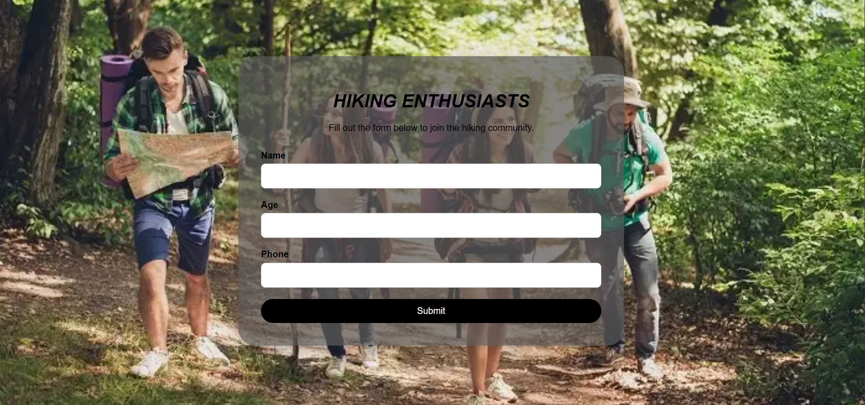

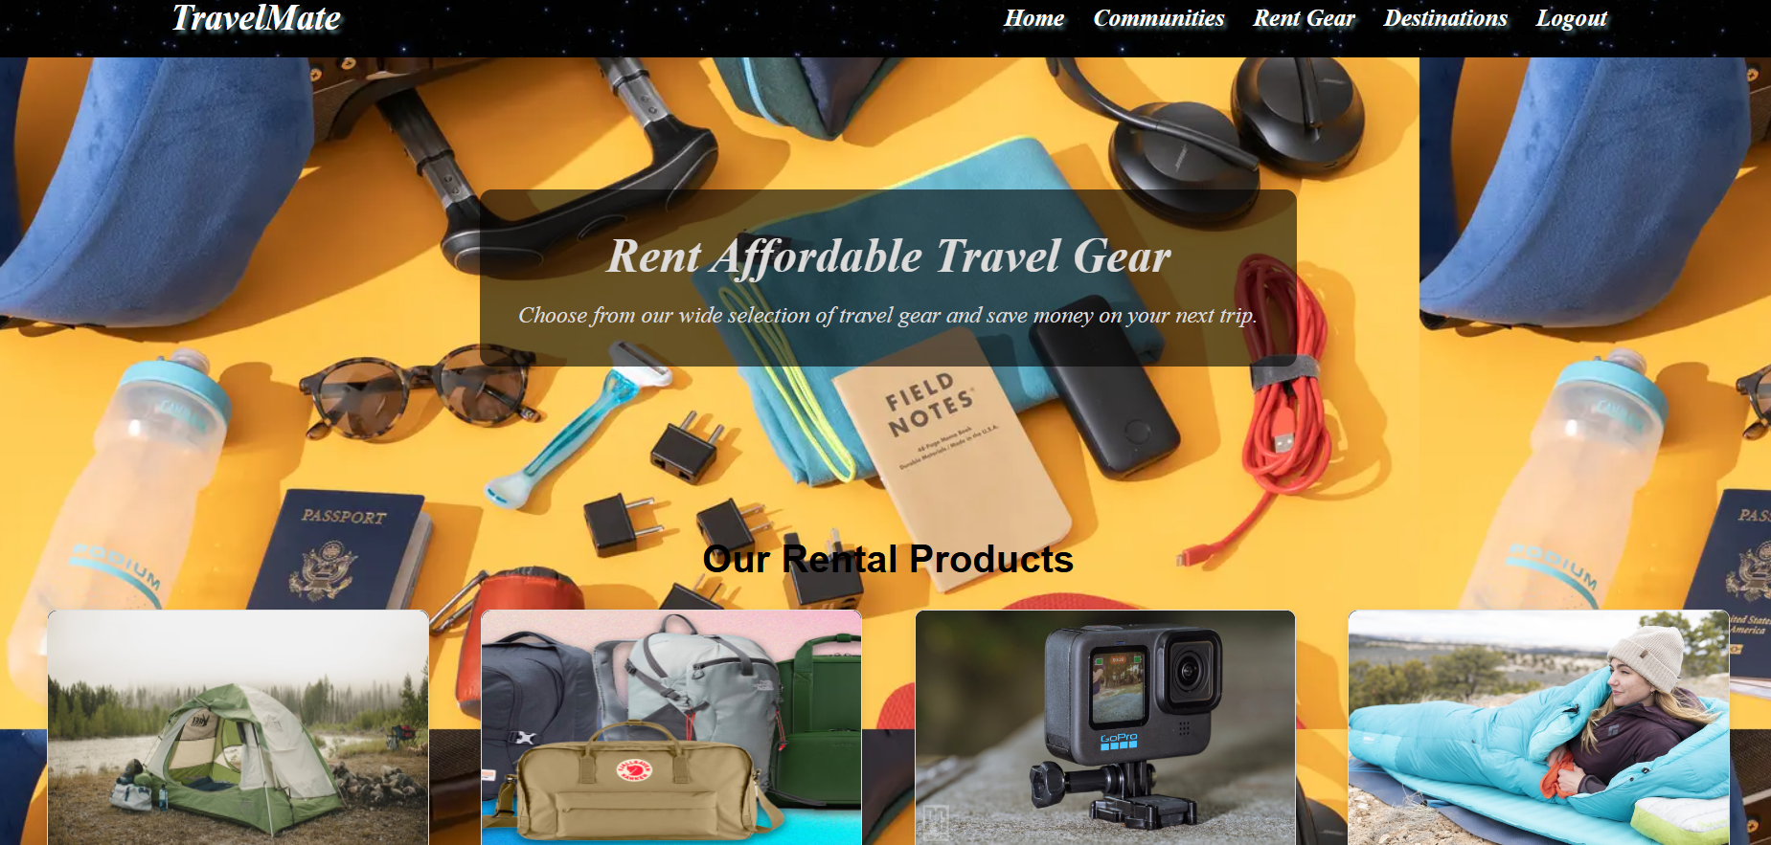

**CHAPTER 8**

**RESULTS AND DISCUSSION**

The TravelMate project has successfully developed a comprehensive platform that meets the evolving needs of modern travelers. By focusing on community-building and cost-effective travel solutions, TravelMate provides a unique blend of social interaction and practical resources that enhance the overall travel experience. The following key results and discussions highlight the platform's impact and effectiveness:

1. Enhanced Community Connectivity

TravelMate's community system has proven to be a vital feature, allowing users to connect based on shared interests, activities, and travel destinations. The platform facilitates:

* Formation of Interest-Based Groups: Users can join or create groups around specific activities, such as hiking, photography, or cultural exploration. This fosters a sense of belonging and camaraderie among travelers, reducing feelings of isolation during solo trips.
* Real-Time Interaction and Support: The ability to share advice, tips, and real-time updates within communities allows for a more enriched travel experience. Users can quickly gather insights about their destinations, leading to better-informed travel decisions and enhanced safety.

2. Cost-Effective Travel Solutions

The integrated rental service addresses a significant barrier to entry for many travelers: the high cost of travel gear. Key findings include:

* Accessibility of Quality Gear: Users can rent high-quality camping, hiking, and photography equipment at affordable rates, making it easier for them to engage in diverse activities without the financial burden of purchasing gear outright.
* Shared Rentals: The option for group rentals encourages users to collaborate, share expenses, and access premium gear without the long-term commitment associated with ownership. This feature is particularly beneficial for group travelers, allowing them to experience activities they might not have tried otherwise due to cost constraints.

3. User Engagement and Feedback

Feedback from users has been overwhelmingly positive, highlighting several aspects of TravelMate that contribute to its success:

* User-Friendly Interface: The platform's design is intuitive and easy to navigate, allowing users of all ages and tech-savviness to engage seamlessly.
* Positive Community Experiences: Testimonials indicate that users have formed lasting friendships and connections through the platform, enhancing their travel experiences and fostering a supportive travel community.
* Impact on Travel Behavior: Many users reported that the availability of rental gear and community support has encouraged them to try new travel experiences and explore unfamiliar destinations with confidence.

4. Future Improvements and Opportunities

While TravelMate has made significant strides, there are several opportunities for growth and enhancement:

* Expanded Gear Inventory: As user demand grows, expanding the range of available rental gear can cater to diverse travel needs, including niche markets like extreme sports or specialized photography.
* Enhanced Features: Implementing additional features such as group trip planning tools, integrated event calendars, and local guides could further enrich user experiences and foster deeper connections among travelers.
* Mobile Application Development: Developing a mobile app could increase user accessibility and engagement, allowing for real-time notifications, easier communication, and on-the-go access to rental services and community interactions.

**CHAPTER 9**

**CONCLUSION**

Overall, TravelMate represents a forward-thinking approach to modern travel, emphasizing community, shared experiences, and financial accessibility. By addressing the needs of both solo and group travelers, the platform not only enhances individual travel experiences but also cultivates a supportive network of like-minded individuals. The successful implementation of this project lays the groundwork for future developments that can further enhance the travel experience and solidify TravelMate’s position in the travel industry.

**REFERENCES**

1. HTML,CSS,JS– https://www.w3school.com/
2. PHP, MYSQL– www.youtube.com
3. Font Awesome Icons– [www.fontawesome.com](http://www.fontawesome.com)